SCHOOL OF PLANNING AND ARCHITECTURE

**UNIVERSITY OF MYSORE**

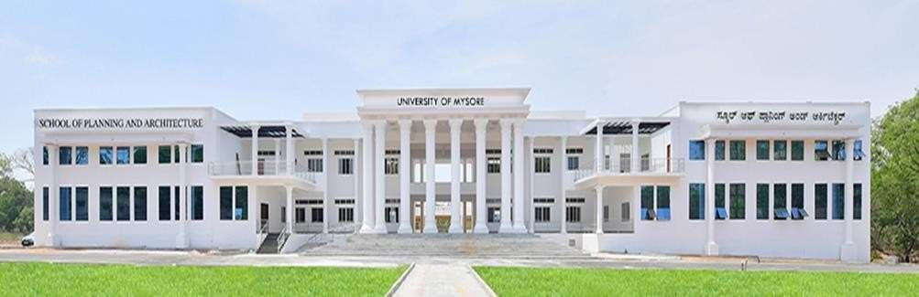

DISTRICT DEVELOPMENT PLAN FOR MYSURU DISTRICT

MAHAM KAUSAR

3 SEM, M. TECH IN URP

P01ZZ23T107004

TOPIC: Urban Core Infrastructure & Rurban Cluster



MASTERS IN URBAN AND REGIONAL PLANNING

SCHOOL OF PLANNING AND ARCHITECTURE